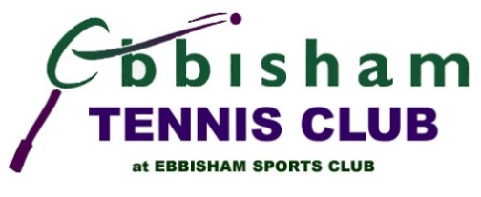 | 2024 CHAMPIONSHIPS  finals day – 31 august

Running order
Court 3 |  | Court 1
Time |  | Time
9.30  Umpire | Junior Orange  2023: Daria Kuzmina  Theo Cahill-Sawford  V  Isma’il Burtally  2024 Champion:  Score: | 9.30  Umpire | Mixed doubles  2023: Liz Rowlands & Arron Knight  Rachel Allen & Simon Woodhouse  v  Diana Poveda & Callum Macarty  2024 Champions:  Score:
10.15  Umpire | Junior Green  2023: Dylan Edge  Rory O ’Rooke  v  Luca de Rosa  2024 Champion:  Score: | 11.00  Umpire | Men’s singles plate  2023: Oliver Eyers  Anil Gogna or Liam Spencer  v  Will Baker-Gonzales or Jon Tasch  2024 Champion:  Score:
11.00  Umpire | Junior 14U  2023: Jessica Kenworthy  Dylan Talbot  v  Alex Eyers  2024 Champion:  Score: | 12.30  Umpire | Ladies’ doubles  2023: Rachel Allen & Bridget Jones  Rachel Allen & Bridget Jones  v  Diana Poveda & Liz Rowlands  2024 Champions:  Score:
12.00  Umpire | Junior 12U  2023: Jessica Kenworthy  Dylan Edge  v  Denis Manole  2024 Champion:  Score: | 14.00  Umpire | Men’s doubles  2023: Rob Crouch & Simon Woodhouse  Hugh & Leo or Dan & Simon  v  Callum Macarty & Liam Spencer  2024 Champions:  Score:
13.00  Umpire | Junior Doubles  2023: Oliver Eyers & Oliver Kopa  Oliver Eyers & Oliver Kopa  v  Alex Eyers & Dylan Talbot  2024 Champions:  Score: | 15.30  Umpire | Ladies’ singles  2023: Jessica Kenworthy  Rachel Allen or Diana Poveda  v  Liz Rowlands or Katherine Shepherd  2024 Champion:  Score:
14.00  Umpire | Junior Girls  2023: Jessica Kenworthy  Helena Steventon  V  Eloise Baker-Gonzalez or Emma Steynberg  2024 Champion:  Score: | 17.00  Umpire | Men’s singles  2023: Arron Knight  Arron Knight or Leo Morrell  v  Callum Macarty  2024 Champion:  Score:
15.00  Umpire | Junior 18U  2023: Oliver Kopa  Oliver Kopa  v  Oliver Eyers or Ryan Skandamoorthy  2024 Champion:  Score:

2024 CHAMPIONSHIPS
finals day – 30 august

Running order to be decided
Time  Umpire | Over 50’s doubles  New event  Rob J & Colin or Paul & Bridget  V  Jon & Chad or Alex T & Anil  2024 Champions:  Score:
Time  Umpire | Over 50’s singles  New event  Colin or Anil  v  Rob Jones  2024 Champion:  Score:

